**Volunteer Process Guide**

6/20/2022

Volunteers are going back to filling out an online application first. Then we will contact them to schedule their hours.

Applications will be stored virtually. Checking in and logging volunteer hours will also be done virtually.

There is a laptop set up specifically for volunteer use next to Rusty Shackleford the Skeleton(on top of local author books for sale). **Use the “ALL” account. Everything needed for volunteers is bookmarked in Firefox. When not in use, please return to our website tab so nobody’s personal information is visible.**

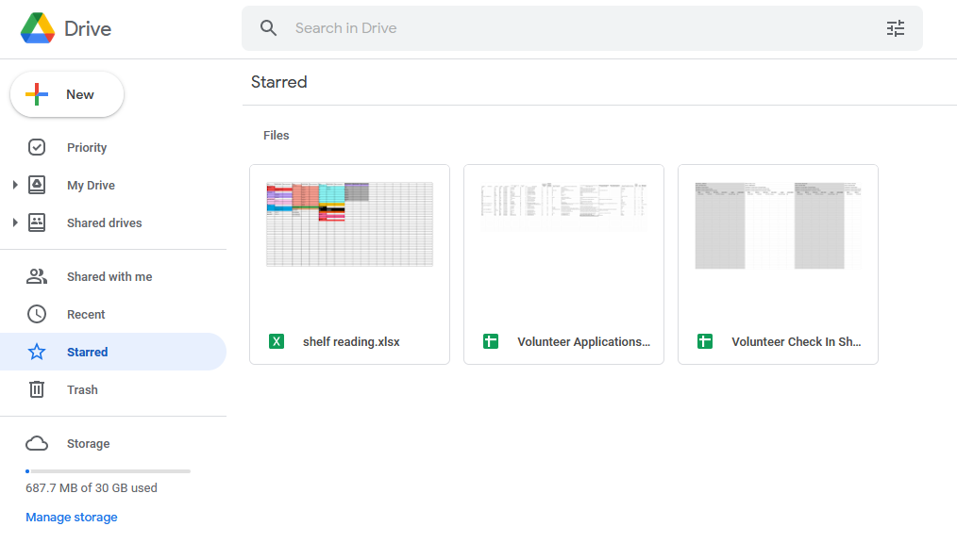Everything can also be accessed from any front desk computer. On Google Drive, click Starred to find the “Volunteer Application” spreadsheet and the “Volunteer Check In” spreadsheet.

Volunteer email: volunteer@fisherlibrary.org   
Password: Volunteertime1289

FOR APPLICATIONS:

Encourage people to apply on our website. Under the programs drop down bar, click volunteer opportunities. Then, click the link for volunteer application under step 1.

Here is what the online application form looks like.

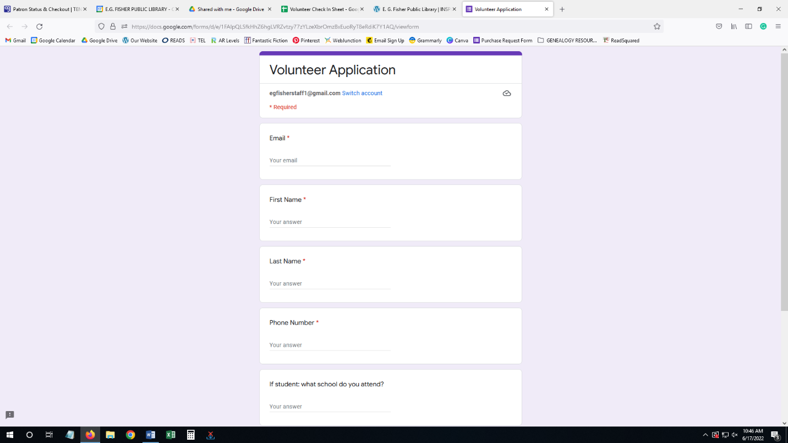

Paper applications are available upon request. Any staff member can transfer/fill an online application with paper information (then shred upon completion) or pass to Meleena.

SCHEDULING VOLUNTEERS:

We will go back to adding volunteers in the google calendar. Be sure to select the correct calendar for volunteers, not for front desk. **Please place the contact phone number and staff initials in the description spot.**

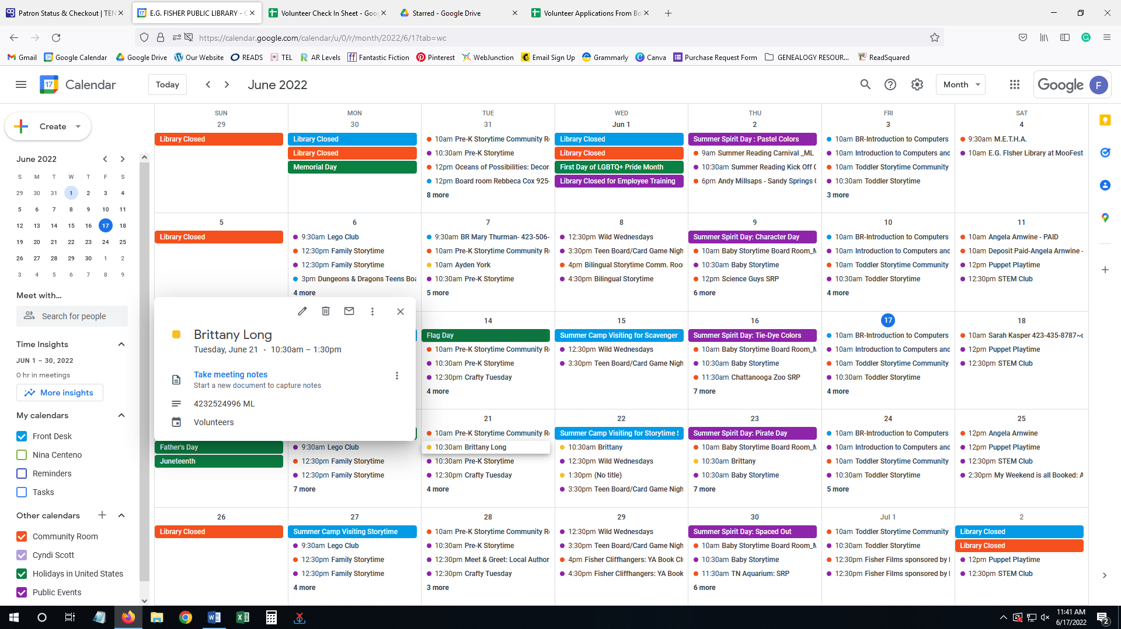

**Please ensure any newly scheduled volunteers have filled out an application.**

Check the Volunteer Application Spreadsheet. If they are missing information (example: email missing) please have them fill it in.

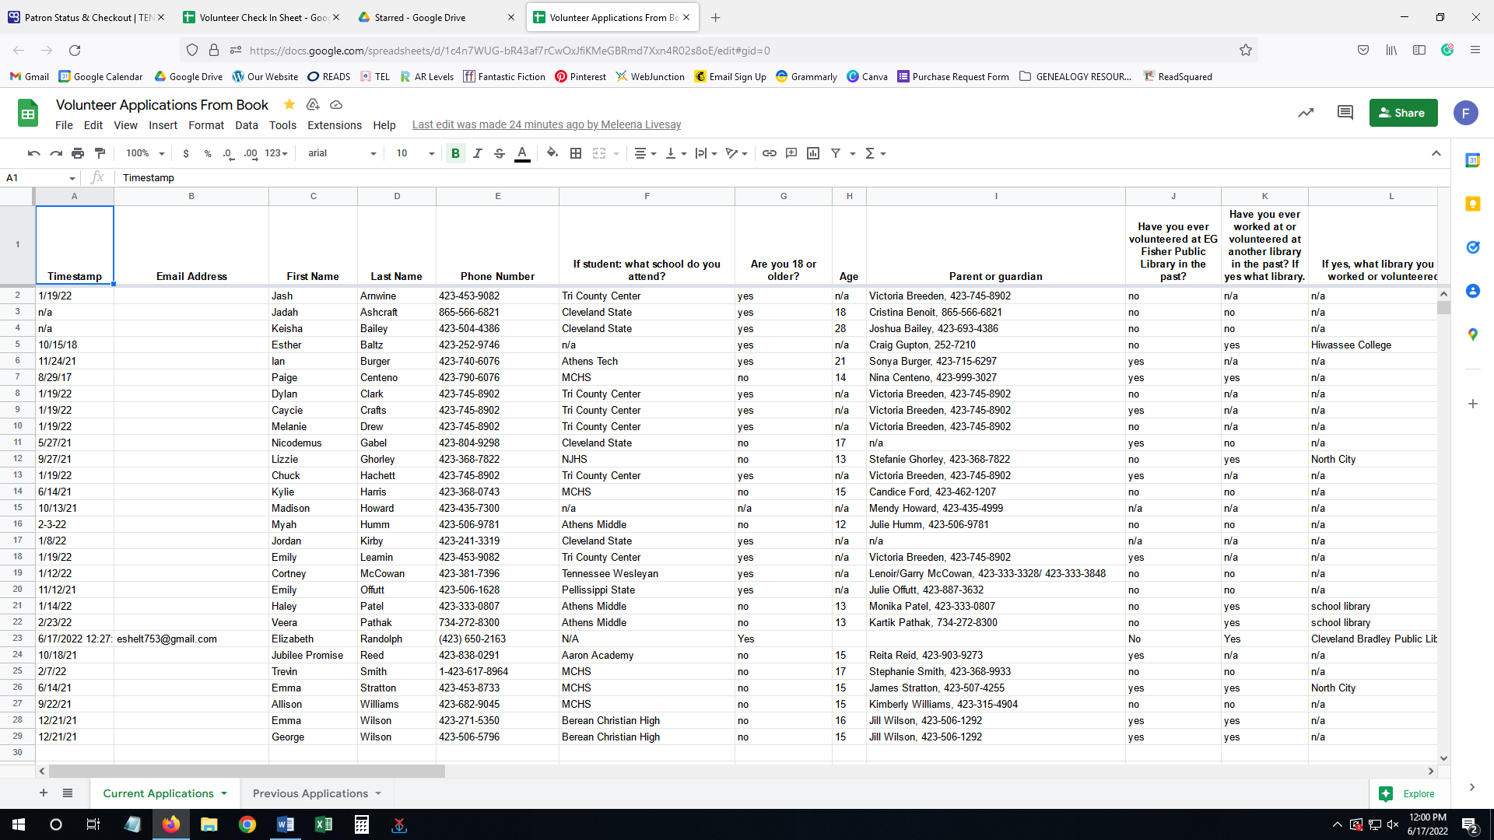

CHECKING IN/OUT (LOGGING HOURS):

Go to the Volunteer Check In spreadsheet.

Step one: select the tab for the volunteer’s last name at the bottom.

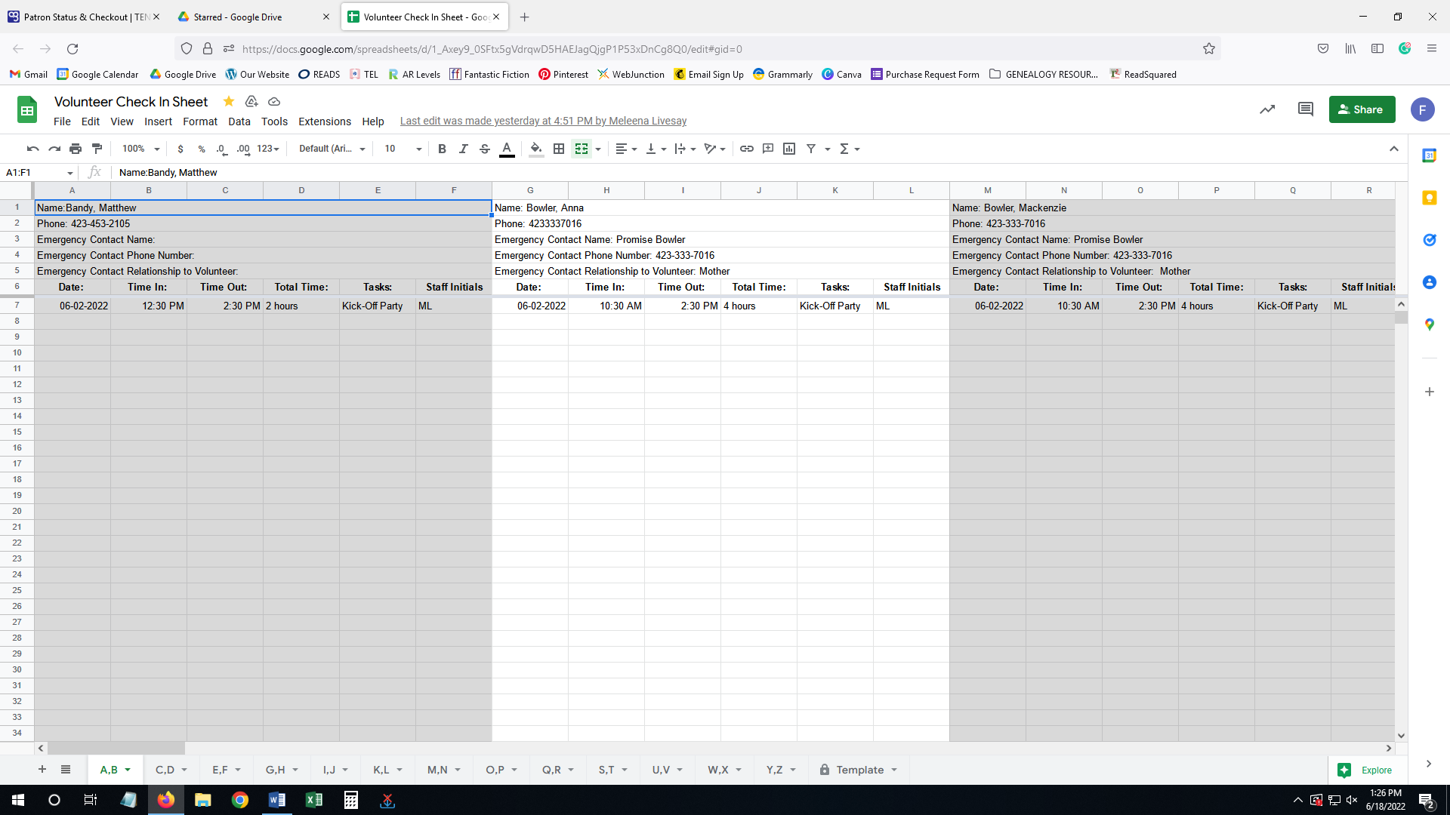

Step two: search for their name (you can use CTRL + F to find or scroll through manually). If they are missing information (example: emergency contact) please have them fill it in.

Step three: insert date, time in/out, total time, tasks, and staff initials. **Volunteers can fill out their own logs, but a staff member will need to fill in the initial portion to verify they were here.**

VOLUNTEER LEVELS:

The check in spreadsheet will reflect the volunteer levels visually through a colored box on their name. Below, we see the first volunteer is level green, the second is level blue, and the third is level white.

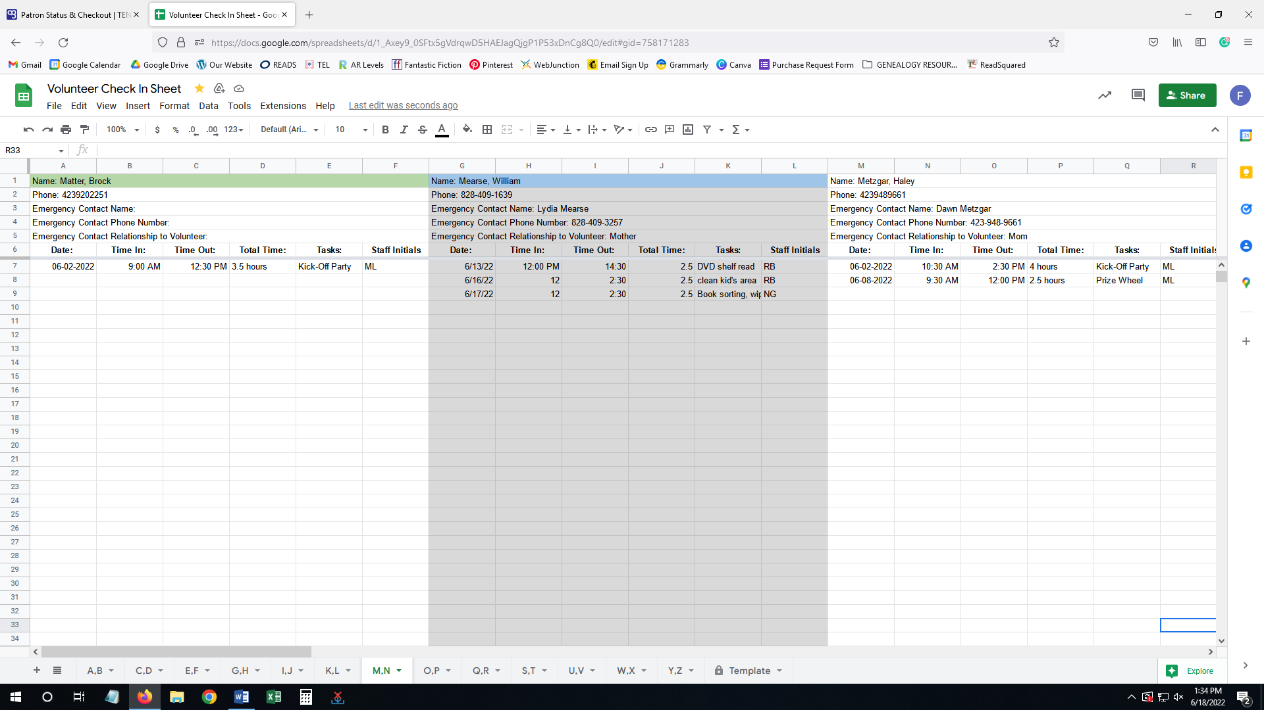

For those volunteers who have moved to a higher level, colored nametags are inside the volunteer binder next to the laptop. **Please have them put their colored nametags back in the binder when they leave so that no one else picks up a tag color they didn’t rightfully earn.**

EXPLANATION OF LEVELS:

White: not allowed to shelf read or put away books.

Able to clean or assist in programs. See the checklist for volunteer tasks.

Green: allowed to shelf read. Can also do any tasks for white level. **Not allowed to put away books.**

How to be promoted to green:

Complete paper test for shelf reading. They can miss up to 2 questions and still pass. *If they failed, add a comment to the box for their name on the check in spreadsheet with the date (left click on name box, click comment).*

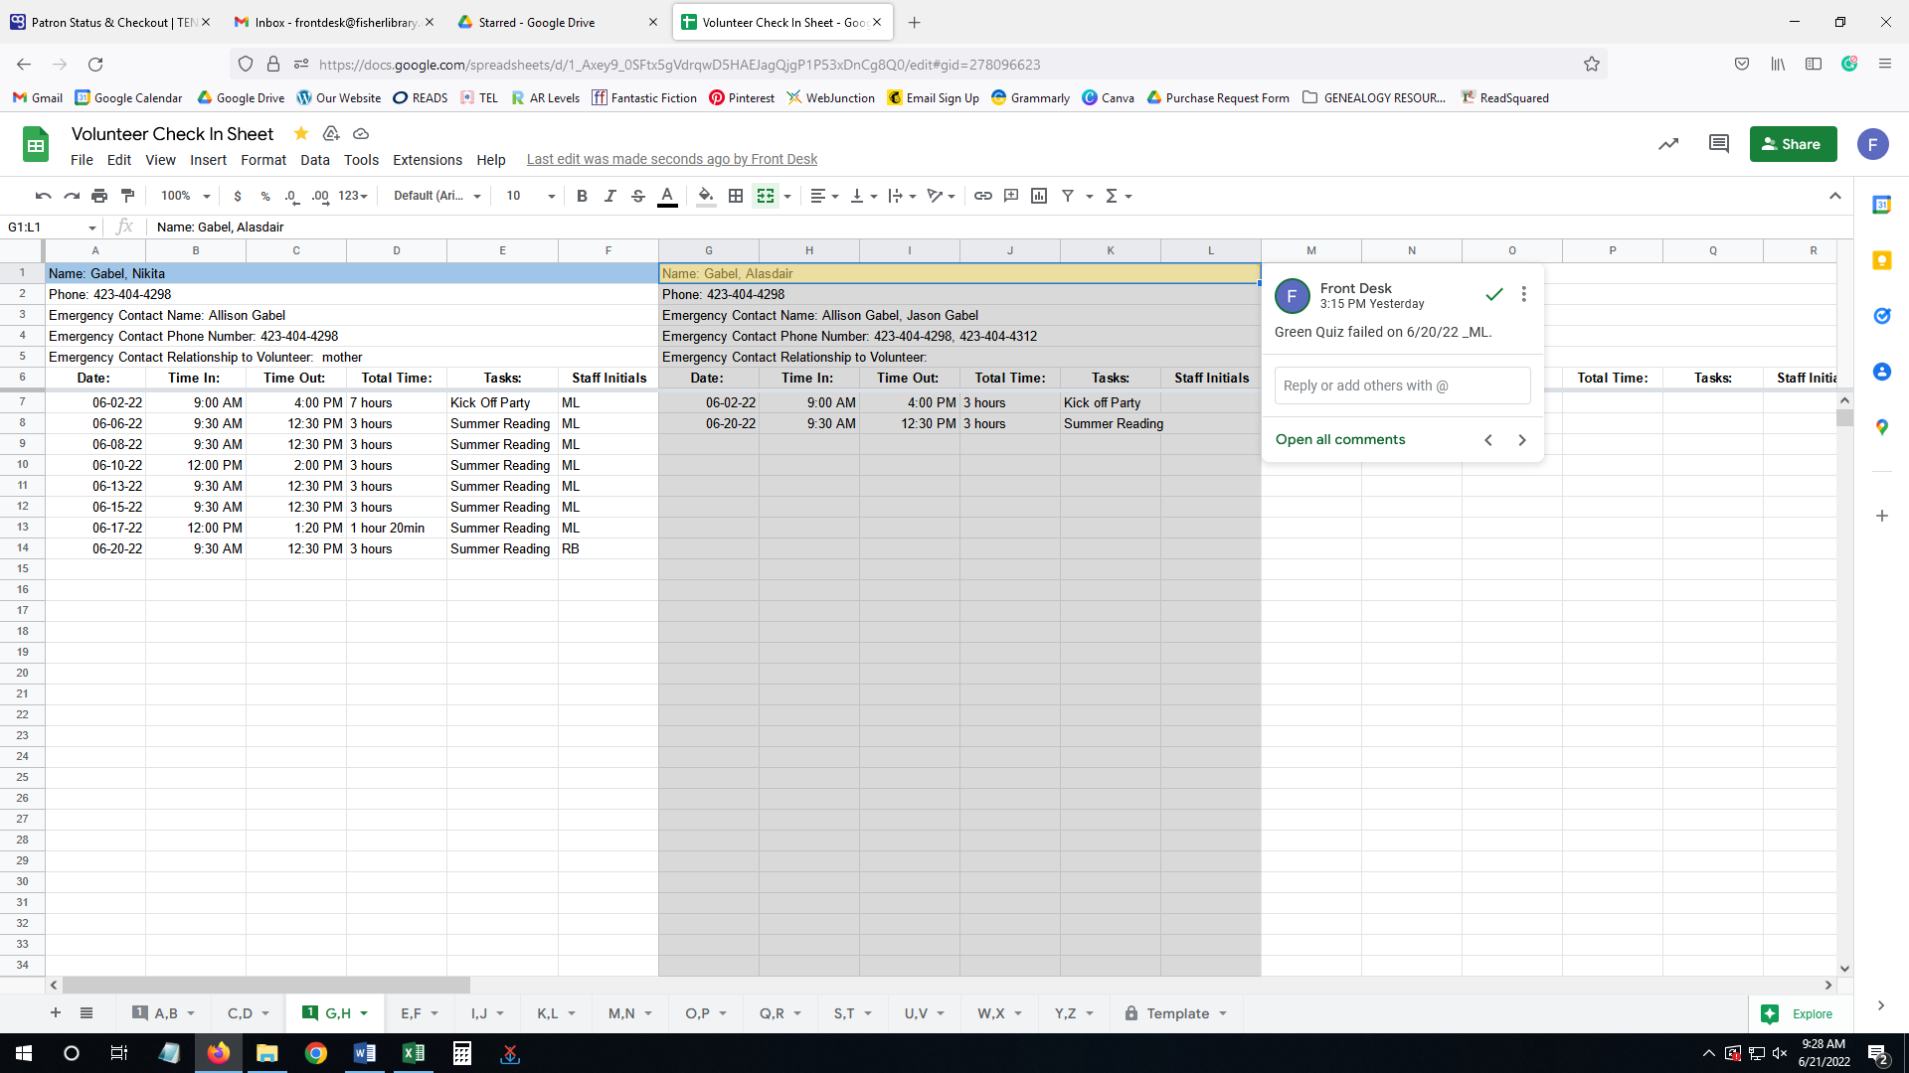 *(cont’d…)*

If they passed, first give them a tour of all the sections. Then, give them a practice aisle to shelf read. **Purposefully misplace 2-3 books and see if they find and put them away correctly.** If they pass the practice aisle, change the box for their name on the check-in spreadsheet to green. Discard the test afterwards.

Blue: allowed to put away books. Can also do any tasks for green or white level.

How to be promoted to blue:

First, be sure they have had a tour of the library and know where each section is. Give them a walk-through explanation of the different spine labels and where they are located on the put away cart. **Be sure to explain to them what the pink tape means (display) and where the books with the yellow new tape belong!**

Then have them complete the paper test for putting away books. They can miss up to 2 questions and still pass. *If they failed, add a comment to the box for their name on the check in spreadsheet with the date.*

If they passed, give them the hands-on test. Have them take a book from each section off the put-away cart and follow them to watch that they put them away correctly. **If you don’t have time to follow them, have them put a slip of blue paper in each book (located in the box by the volunteer laptop) and go check afterwards when you have time.** If they pass the hands-on test, change the box for their name on the check-in spreadsheet to blue. Discard the test afterwards.

ON SHELF-READING:

*If any volunteer shelf reads, please notate any aisles completed on the shelf reading spreadsheet on google drive.*

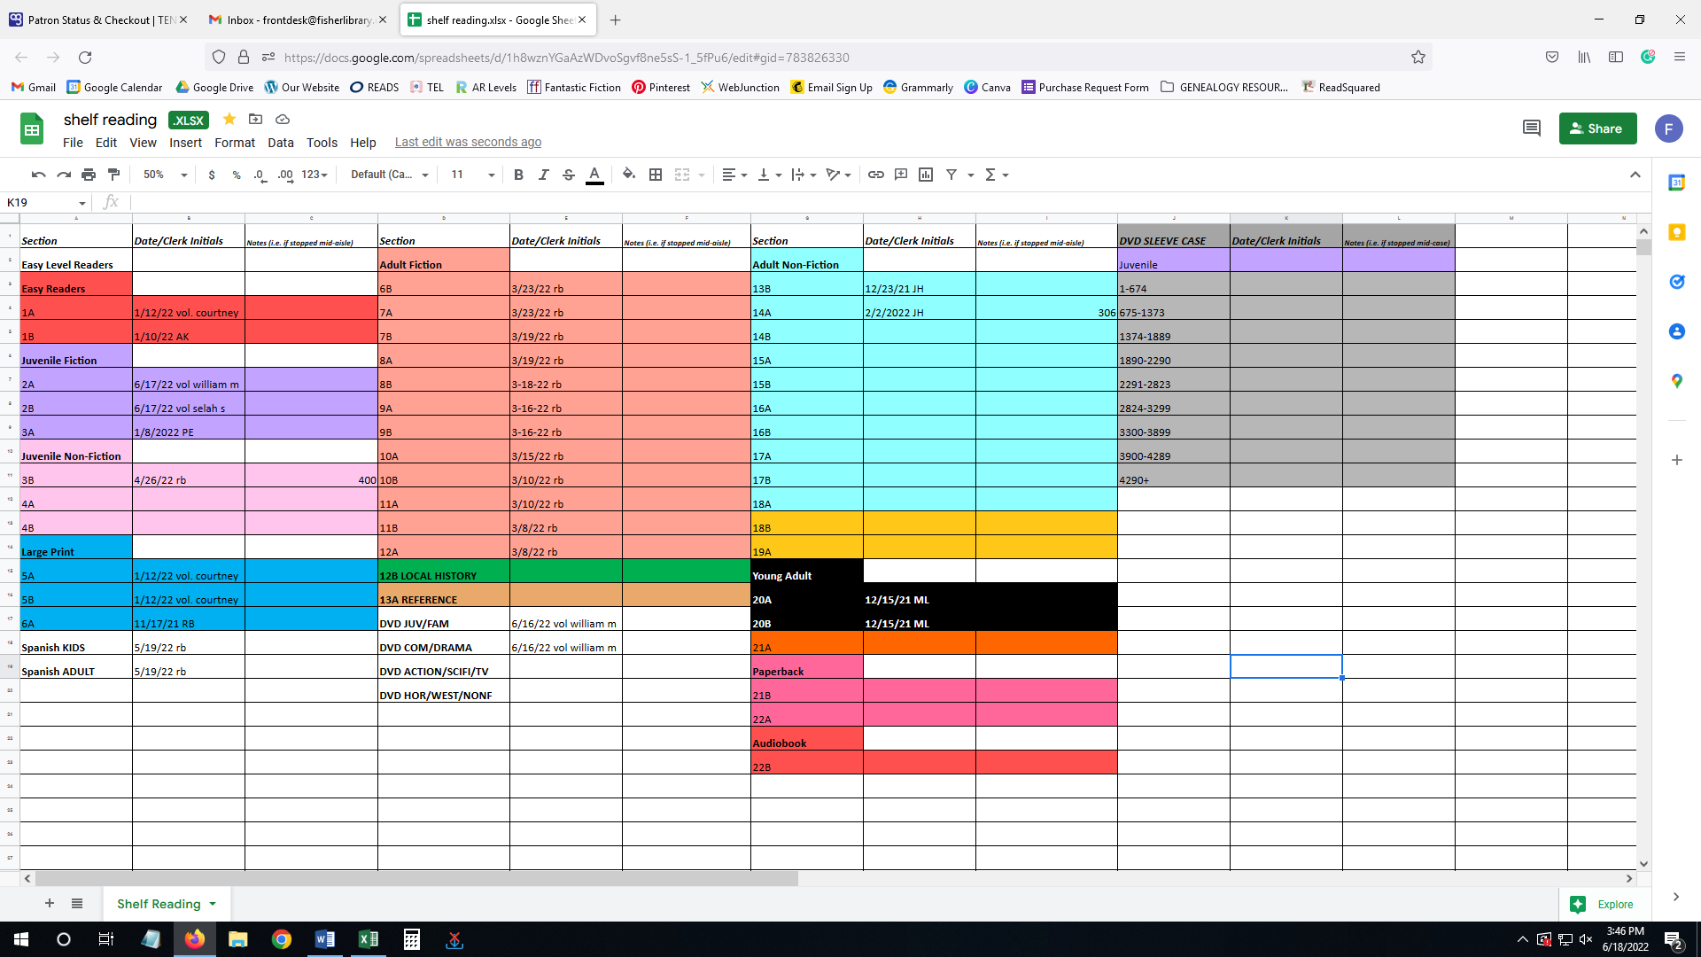

AVAILABILITY CHANGES FOR CURRENT VOLUNTEERS:

On the website, follow the same process to get to the application. There is a link to update availability for current volunteers. It is a google form like the one for the application. Paper forms are still available upon request.

